Computer Language Coding Concepts

Explicit Get & Set Arguments
This article sheds light on explicit Get & Set argument notations. Several notations are introduced. It is not clear yet which is the best one.

Things are often implicitly notated. However, the notation of the Get and Set arguments is always explicit.

The most explicit way to draw out a call to a system command with an argument is as follows:

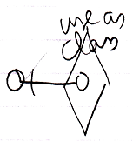

It is notated as a calling the overloaded Use As Class command, with its argument filled in.

But this notation is also possible:

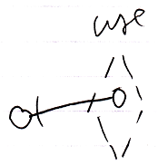

Then you express the aspect implicitly using a different line type for the diamond. You also leave out the aspect from the identifier.

So the aspect can be expressed with a diamond line type or by explicitly expressing the aspect in the identifier.

Get, Set and Use commands are never used on their own. They always need another counterpart. The notation below shows two system command counterparts with explicit arguments:

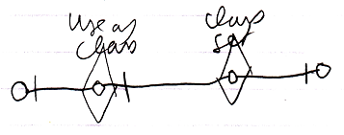

The Class Set argument is connected to the Use As Class argument.

The following notation expresses the same thing:

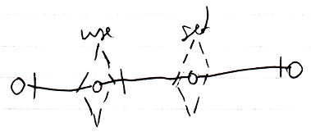

But now the aspect is implicitly expressed by the line type of the command calls.

Note that all explicit Get and Set argument notations use a solid object line between arguments, because that is the part that is explicit. Other parts of the notation are implicit sometimes.

If only the object aspect is adressed, the picture looks like this:

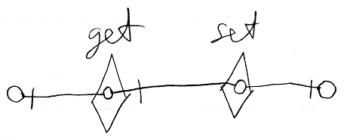

There is also the following weirder possibility to display the Get and Set arguments:

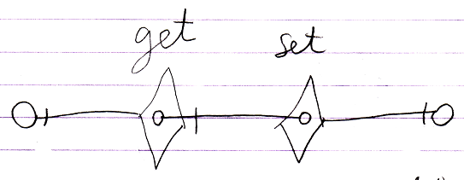

But the odd thing about that notation is that there is no connection between the Get and Set arguments and the real Get and Set targets. The notation looks so strange, that we will probably never go with that.

The main point is: the diagrams above show the explicit expression of the arguments of Get and Set calls.

Explicit display of Get and Set arguments is hardly ever used, because there are simpler notations available, such as the assignment notation or if you must, the explicit Get & Set notation:

Assignment
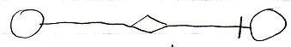
Object Get ←
Object Set →
Explicit Get & Set
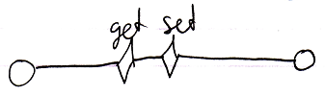
Object Get ←
Object Set →
Explicit Get Set
Object Get ←
Object Set →

You would only use explicit display of Get and Set arguments in abstract diagram expression when you just want to make a point.

See also: System Objects

Author & Copyright: Jan-Joost van Zon Date: August 8, 2009 – August 11, 2009 Location: Oosterhout, The Netherlands Status: Finished

